**Experiment No.4**

**Title:** Implementation of K- Means clustering algorithm for a given case study.

**Batch: B2 Roll No.: 16010420117 Experiment No.: 4**

**Aim:** Implementation of K- Means clustering algorithm.

___________________________________________________________________________

**Resources needed:** Any RDBMS, Java

___________________________________________________________________________ **Theory:**

Cluster analysis or clustering is the process of partitioning a set of data objects (or observations) into subsets. Each subset is a cluster, such that objects in a cluster are similar to one another, yet dissimilar to objects in other clusters. The set of clusters resulting from a cluster analysis can be referred to as a clustering. **Types of clustering:**

**Hierarchical algorithms**:

Hierarchical algorithms find successive clusters using previously established clusters. These algorithms usually are either agglomerative ("bottom-up") or divisive ("topdown"). Agglomerative algorithms begin with each element as a separate cluster and merge them into successively larger clusters. Divisive algorithms begin with the whole set and proceed to divide it into successively smaller clusters.

**Partitioning algorithms**:

Partitioning algorithms typically determine all clusters at once, but can also be used as divisive algorithms in the hierarchical clustering e.g K-mean, K-medoid.

**Density-based clustering algorithms**:

Density-based clustering algorithms are devised to discover arbitrary-shaped clusters. In this approach, a cluster is regarded as a region in which the density of data objects exceeds a threshold. DBSCAN and OPTICS are two typical algorithms of this kind.

**K-Means clustering Algorithm:**

The *k*-means algorithm assigns each point to the cluster whose center (also called centroid) is nearest. The center is the average of all the points in the cluster — that is, its coordinates are the arithmetic mean for each dimension separately over all the points in the cluster.

The basic step of k-means clustering is simple. In the beginning determine number of cluster K and assume the centroid or center of these clusters. Take any random objects as the initial centroids or the first K objects in sequence can also serve as the initial centroids.

Then the K means algorithm will do the three steps below until convergence

Iterate until *stable* (= no object move group):

1. Determine the centroid coordinate
2. Determine the distance of each object to the centroids
3. Group the object based on minimum distance.

__________________________________________________________________

**Procedure / Approach /Algorithm / Activity Diagram:**

1. Download the dataset available at [https://www.kaggle.com/code/vineetverma/clustering-bank-complaints/notebook.](https://www.kaggle.com/code/vineetverma/clustering-bank-complaints/notebook) Identify attributes suitable for applying K-mean clustering

2. Apply some preprocessing techniques to drop some columns.

1. Draw a box plot to visualize the data.
2. Implement K-mean clustering on your dataset for clustering different types of complaints.
3. Evaluate the performance of your algorithm with suitable technique.

___________________________________________________________________________

**Results: (Program printout with output / Document printout as per the format)**

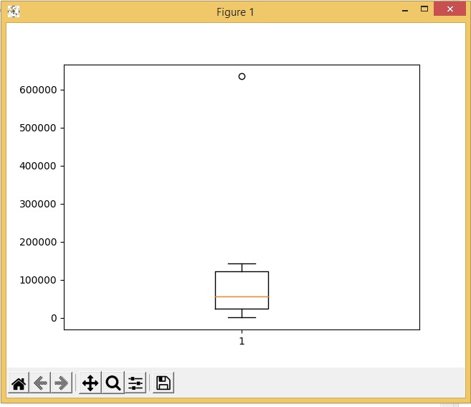**3.) Boxplot**

1. **Kmean clustering code:**

|  |
| --- |
| import matplotlib.pyplot as plt import pandas as pd import numpy as np from sklearn.cluster import KMeans  df = pd.read_csv('Consumer_Complaints.csv') df.drop(['Sub-issue','Consumer complaint narrative','Company public response','Consumer consent provided?','Tags'],axis=1,inplace=True)  dicti={'Email':0,'Fax':0,'Phone':0,'Postal mail':0,'Referral':0,'Web':0} for i in df['Submitted via']: dicti[i]+=1  plt.boxplot(dicti.values()) plt.show()  s = set(df["Issue"]) dicti2 = {} for i in s: dicti2[i] = 0  for i in df["Issue"]: dicti2[i]+=1 print(dicti2)  dicti3 = [] for i in range(len(dicti2)): dicti3.append(i)  x = dicti3 y = dicti2.values() data = list(zip(x, y))  kmeans = KMeans(n_clusters=1) kmeans.fit(data)  plt.scatter(x, y, c=kmeans.labels_) plt.show()  ytest = list(y)[100:] ypred = kmeans.predict(list(zip(x[100:],list(y)[100:]))) print("Accuracy : " , (r2_score(ytest, ypred))*100 , |

**Output:**

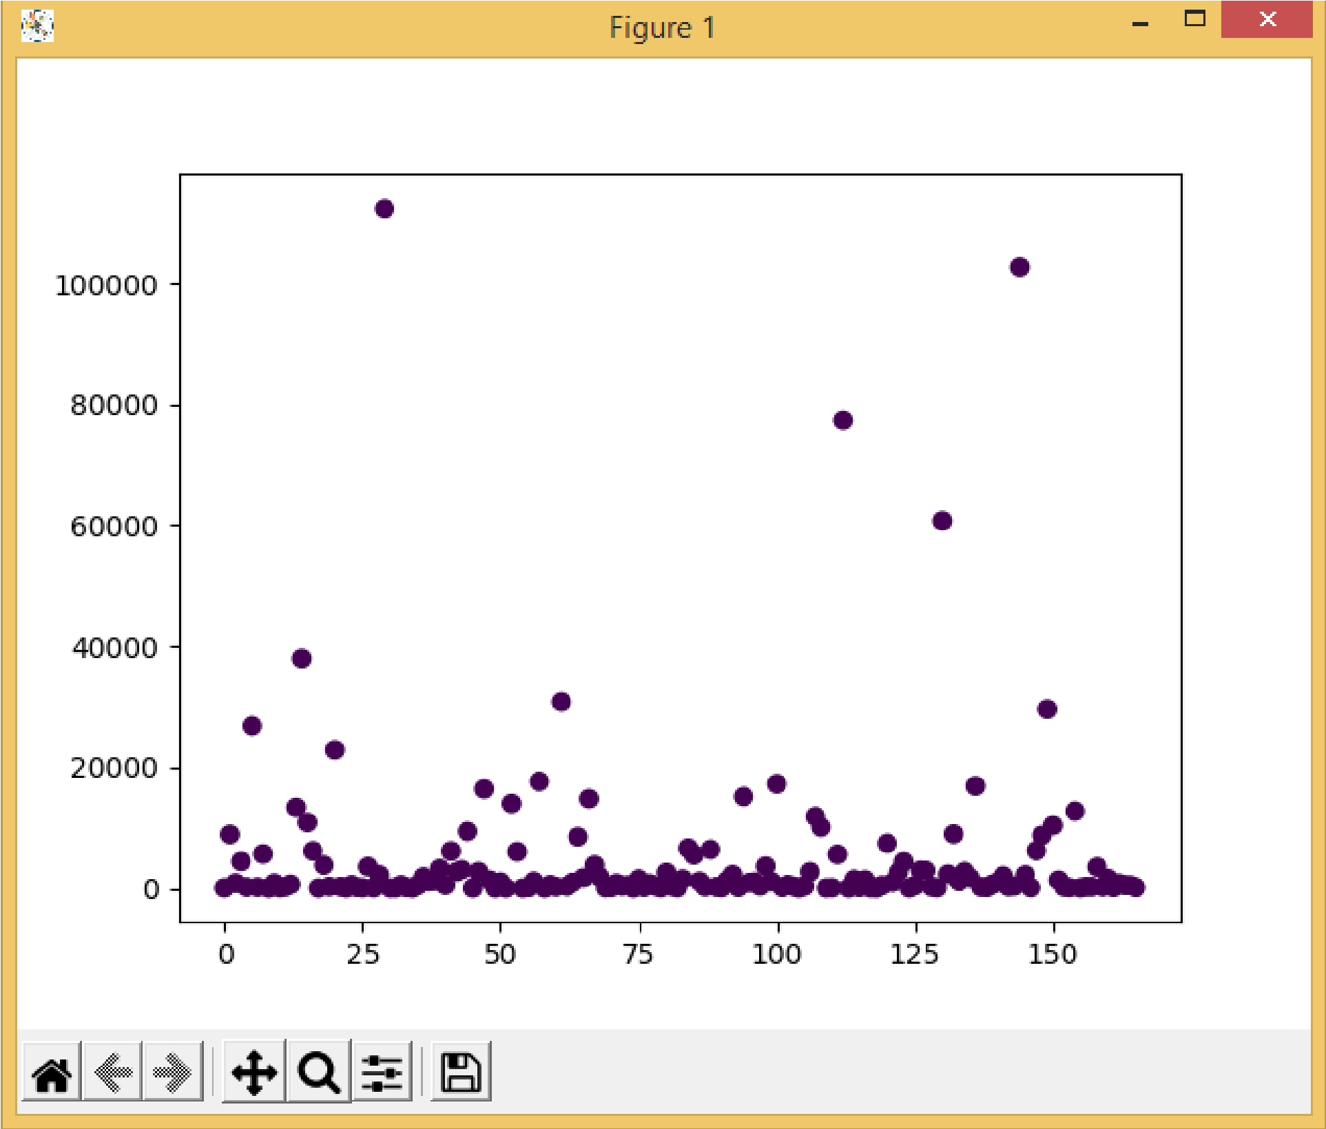

1. **Evaluation:**



**Questions:**

1. What are advantages and disadvantages of K-means clustering algorithm?

**Ans:**

**Advantages of k-means**

* Relatively simple to implement.
* Scales to large data sets.
* Guarantees convergence.
* Can warm-start the positions of centroids.
* Easily adapts to new examples.
* Generalizes to clusters of different shapes and sizes, such as elliptical clusters.

## Disadvantages of k-means

* **Choosing**k**manually.**
  + Use the “Loss vs. Clusters” plot to find the optimal (k)
* **Being dependent on initial values.**
  + For a low k, you can mitigate this dependence by running k-means several times with different initial values and picking the best result. As k increases, you need advanced versions of k-means to pick better values of the initial centroids (called **k-means seeding**).
* **Clustering data of varying sizes and density.**
  + k-means has trouble clustering data where clusters are of varying sizes and density.
* **Clustering outliers.**
  + Centroids can be dragged by outliers, or outliers might get their own cluster instead of being ignored. Consider removing or clipping outliers before clustering.

**Outcomes: CO3: Comprehend radial-basis-function (RBF) networks and Kernel learning method**

**Conclusion: (Conclusion to be based on the objectives and outcomes achieved)**

We conclude that we were able to implement the K-means clustering algorithm.

**Grade: AA / AB / BB / BC / CC / CD /DD**

Signature of faculty in-charge with date

___________________________________________________________________________ **References:**

Books/ Journals/ Websites:

1. Han, Kamber, "Data Mining Concepts and Techniques", Morgan Kaufmann 3nd Edition